Table of Contents

Project Scope 2

Purpose 2

Goal 2

Features 2

Page content Details 2

Home 2

Purpose of the Home Page 2

School page 2

Purpose of the page 2

Tutor 3

Purpose of the page 3

Student 3

Purpose of the page 3

# Project Scope

## Purpose

The main purpose of the website is to provide the knowledge to the School about tutors and subjects which is available on the website.

## Goal

The main goal of the website to Give the more subjects to the students and gain more information related to the school which is available on the website.

## Features

User friendly

* This is the secure website which can be easily accessible on mobile phones and pc as well.

## Target audience

* All children above 3 years

# Page content Details

## Home

### Purpose of the Home Page

As the home page is known as main page, I have provided the main information about the website.

Also, some information is providing about the website on homepage.

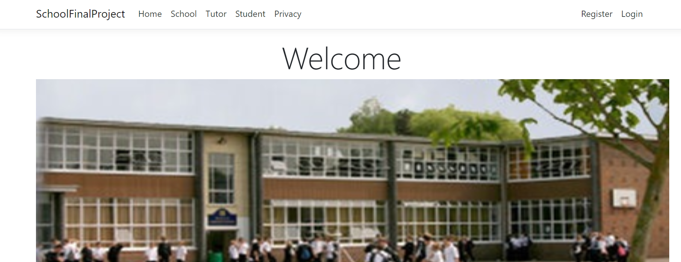

## School page

### Purpose of the page

This page contains all the information about Schools which is available on website.

Registered users can also edit, create and delete details on this page.

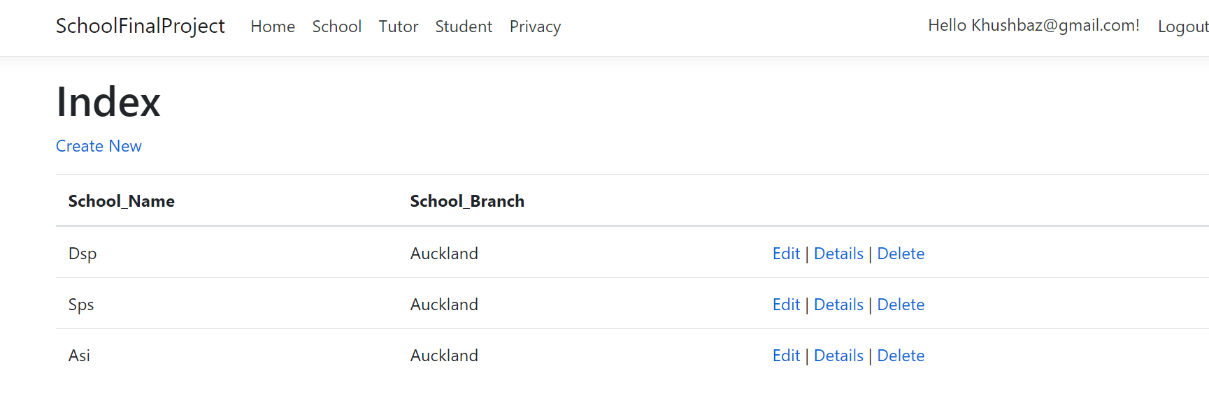

## Tutors

### Purpose of page

On this page people can see all the Tutotrs which is available.

Authorise users only create, edit and delete tutors on this page.

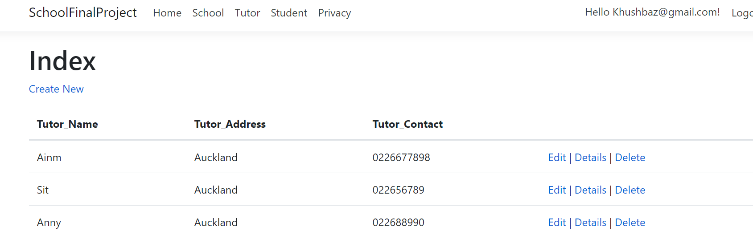

### Students

# Purpose of the page

The purpose of this page to provide details that which movie is available in which school.

Authorize user can edit, create and delete the show details from this page.

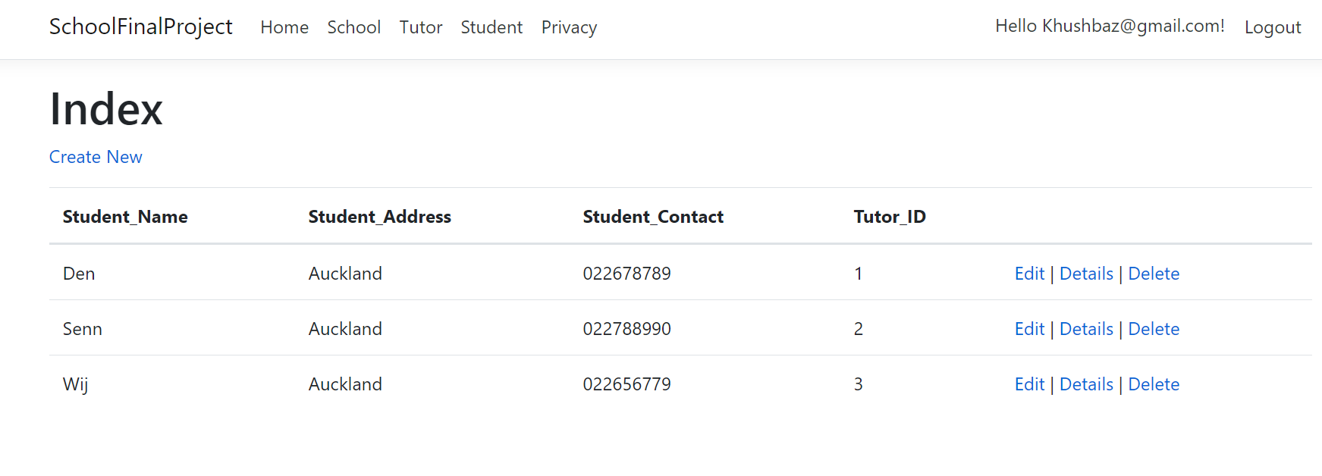

# Register login page.

# Purpose of Register login page

This page Helps to create registration for this website. People who register to this website can do all the operation on website.

